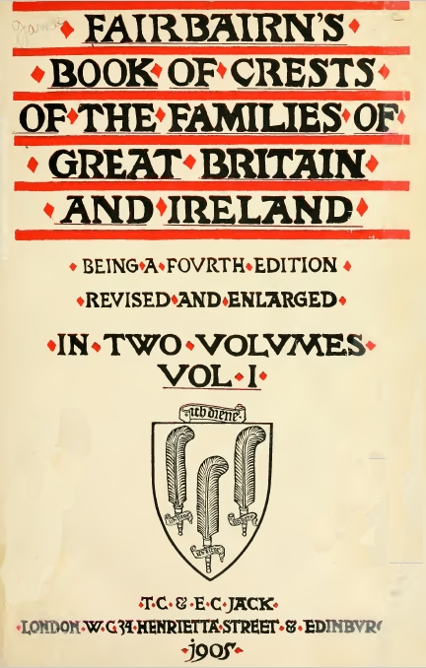

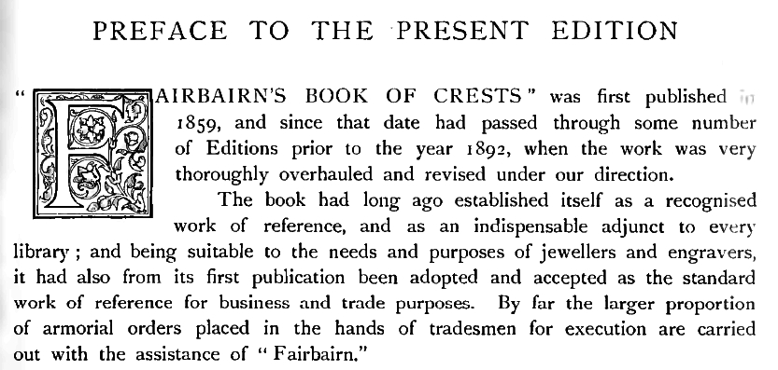

Details of the crest for
Philip Berney Ficklin, Esquire,
of Tasburgh Hall (page 200)

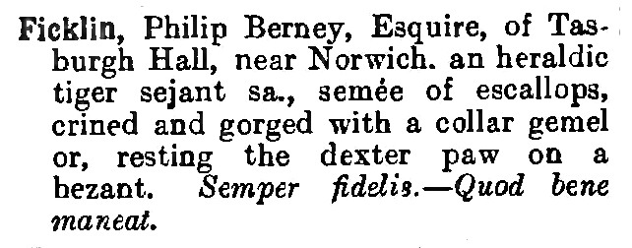

Transcript with meanings in []

Ficklin, Philip Berney, Esquire, of Tasburgh Hall, near Norwich, an heraldic tiger [tiger with a hooked talon at the nose and a mane formed of tufts] sejant [sitting on haunches] sa. [salient, leaping or springing, the hind feet down], semee [sprinkled evenly over the surface at regular intervals] of escallops [scallop shells], crined [relating to the hair] and gorged [with a coronet, collar, ribbon, chain, etc., about the neck or throat] with a collar gemel [double bar or two bars near and parallel to each other] or [gold], resting the dexter [right] paw on a bezant [a flat circular piece of gold, supposed to represent the gold coin of that name]. Semper fidelis [forever faithful]. – Quod bene maneat [insofar as best remains].

